Monitoring Well Inventory Survey Plan (Version B)

New Jersey Department of Military and Veterans Affairs Facilities
2019

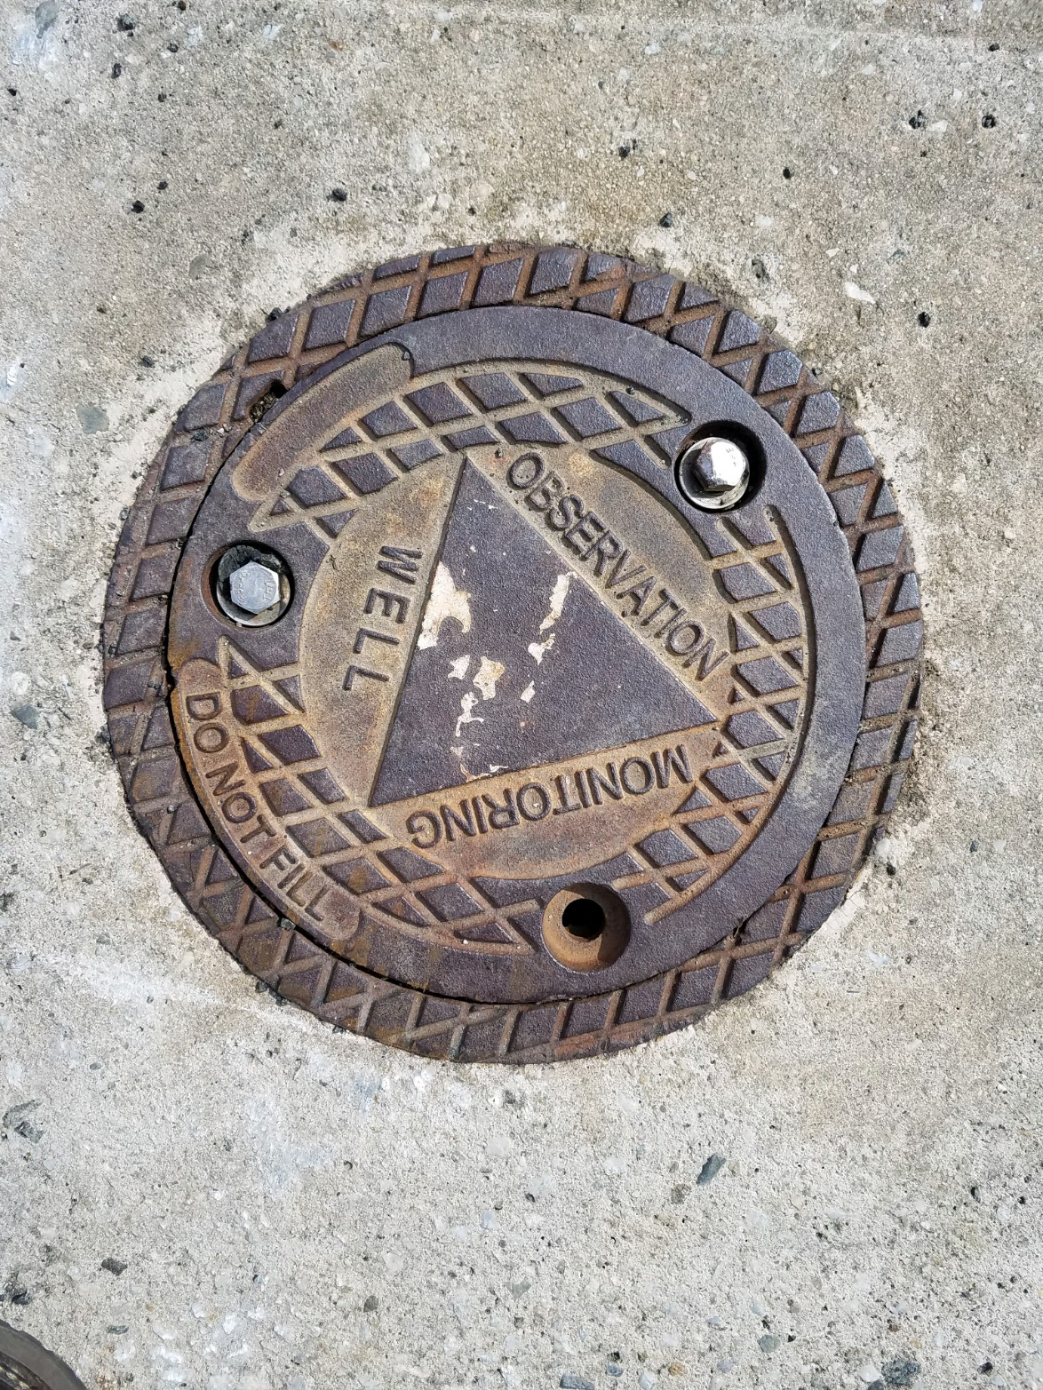

Prepared by the Stockton University Environmental Internship Program
John Hallagan and Nicholas Gamarro

- Introduction
The purpose of this survey is to field verify the existence of wells (monitoring, irrigation, potable water, etc) located on the properties of 25 New Jersey Army National Guard (NJARNG) facilities, listed in Appendix B. Facility maps are present in Appendix D. The goals of this project are as follows:

  - Verify the existence of wells at those facilities
  - Ensure all wells have their well permit numbers permanently affixed
  - Label each well with their assigned permit number
  - Provide accurate coordinates for use in the NJARNG Global Information System (GIS)
  - Provide accurate records of existing and decommissioned wells
  - Assess well integrity and condition
  - Measure volatile organic compound (VOC), lower explosive limit (LEL), hydrogen sulfide (H2S), carbon monoxide (CO), and oxygen (O2) concentrations of each well
  - Organize all records into a physical/hard copy file and duplicate the records on the NJARNG electronic document control library.

Each well will be identified and verified on-site to ensure that current well records are accurate. There are eight variations of wells that may exist at each facility; monitoring, irrigation, injection, boring, dewatering, recovery, extraction, and potable water. The vast majority of these wells fall in the monitoring category, their purpose being to monitor the groundwater for potential contaminants. The conditions of each well will be recorded, noting any corrosion, damage, missing hardware, or destruction. Using a multi-gas monitor, the volatile organic compound (VOC), lower explosive limit (LEL), hydrogen sulfide (H2S), carbon monoxide (CO), and oxygen (O2) concentrations will be recorded to detect the presence of potentially harmful contaminants in each well. All wells should be in good condition, with the caps and casings intact and not leaking. If well caps are missing, or well caps and casings cracked, it can enable potentially contaminated surface water to enter the groundwater. For monitoring wells, compromised caps or casings can cause readings taken by photoionization detectors (PIDs) or multi-gas monitors to be inaccurate, especially if well plugs are effected. This can result in potentially significant groundwater contamination to be passed off as minor.

All wells must have their 10-digit permit numbers permanently affixed to them for quick and easy identification. As per N.J.A.C. 7:9D-2.4(a)1, each well missing their permit numbers must have them replaced immediately. Tags with the well permit numbers will be weather-resistant and be affixed to the wells using a weather-resistant adhesive.

If necessary, well caps deemed to be damaged or in poor condition will be replaced with new well caps. Tags for well caps will be ordered and placed in the proper indentation for any tags.

The GPS coordinates of each well will be updated using modern GPS equipment. This will enable future surveyors to easily pinpoint the location of each well at each site, as well as provide spatial data for making GIS maps of each facility. Mapping out each well will provide a quick and easy reference for any surveyors or inspectors.

Field-verified wells will have their records and information updated. All documents with incorrect information will be updated with the correct information regarding their respective wells. Some wells have been decommissioned since they were last surveyed and decommissioning records are not available. Missing documents will be printed out and added to current records. These documents should be organized for future convenience when they are needed again.

II. Plan of Action

For each well on record at their respective facilities, the following will be recorded on data sheets “Well Inventory Field Data Sheet - Location and Condition ” and “Well Inventory Field Data Sheet - Emissions Data”.

In order to prepare manhole replacement, if applicable, a temporary permit number and/or well ID will be applied to the well cap itself or the concrete foundation around the well. Temporary IDs will be applied using a bright-colored spray paint that should remain legible for several weeks. This is to allow contractors to properly identify the well and replace the old well cap with the properly labeled new one.

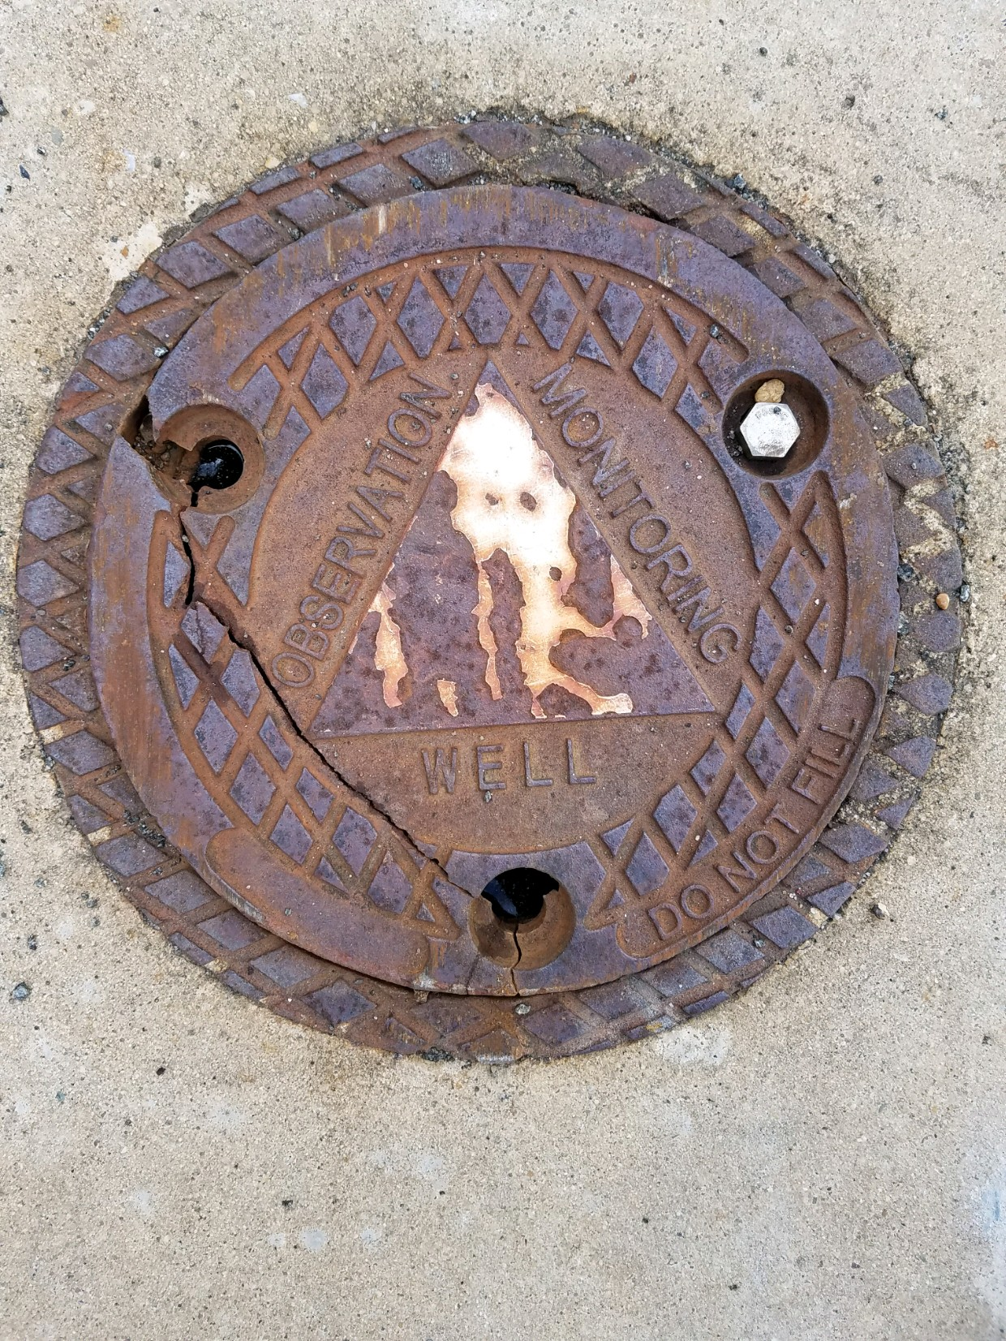
New well caps will have a metal tag affixed to them displaying their 10-digit permit numbers and field names.

For Damaged, Destroyed and/or Lost Wells

Damaged wells will show obvious physical signs of damage. For stick-up wells, this includes the casing being bent or cracked. For flush-mount wells, this includes the concrete base the well is set in being cracked or significantly chipped, and the cap being cracked or missing. For any well, if the underground portion of the casing is buckled or cracked, it shall be considered damaged.

A well will be classified as “destroyed” if the well is no longer present or is damaged beyond repair. For stick-up wells, this would include the above ground portion of the casing being knocked over completely or severed. Wells that are filled in with debris or other material will also be labeled as destroyed.

Wells considered lost will not have their location on record despite records stating the existence of said well. They are also considered lost if their GPS coordinates are incorrect, and cannot be located by surveyors.

As per N.J.A.C. 7:9D Subchapter 3, monitoring well owners or their agents are obligated to contact the Bureau of Water Allocation and Well Permitting (BWAWP) in writing in the event of wells being damaged, destroyed, or lost.

If wells are considered damaged, destroyed, or lost, the following information must be submitted:

- The name, address, telephone number of the responsible party/property owner for the well
- The facility, the county and township it is in, the block and lot numbers, the coordinates of the well
- Date the well was discovered to be damaged, destroyed or lost
- The approximate date of when the well was damaged, destroyed or lost
- Circumstances which resulted in the well being damaged, destroyed or lost
- In the case of lost wells, the actions taken to locate the wells. In the case of damaged or destroyed wells, the actions taken to clear obstruction to facilitate decommissioning
- Well permit number

III. Field Methods

General Surveying
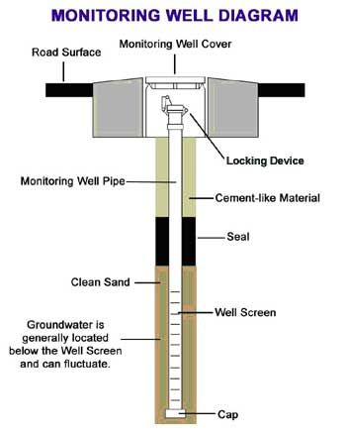
For each well, surveyors will record the field name of the well (eg. MW-1), along with the 10-digit well permit number that should be affixed to the well manhole. Updated GPS coordinates will be recorded for use with GIS software and to ensure that wells can be easily located in the future. Reference pictures will be taken for each well to display their conditions and their physical appearances.The current status of each well will be documented, stating whether or not the well is still in use or has since been decommissioned. This data will be recorded on the “Monitoring Well Inventory- Field Sheet” for each site.

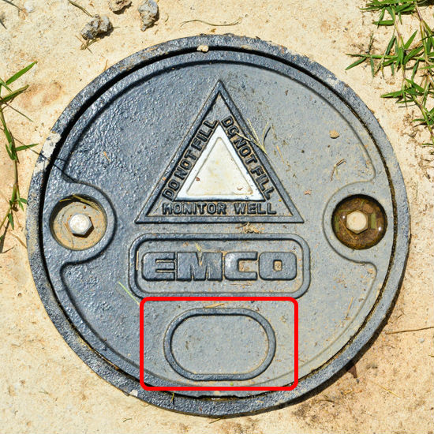
For flush mount wells, a socket wrench will be required to remove bolts keeping well manhole in place. If the headspace of the well is filled with water, drain prior to removing the well’s plug. The well’s plug, if locked in place with a padlock, will require a key. If a key cannot be located, or the lock will not detach, bolt cutters will be used.

For stickup wells, a socket wrench will be required if the cap uses bolts. For caps affixed with a padlock, the proper key for the padlock will be needed to gain access to the well. If a key cannot be located, or the lock will not detach, bolt cutters will be used.

Because damaged and/or poorly conditioned well caps will be replaced with newer ones, their respective wells will need to be marked for identification. Using a spray or marker paint, the permit number of each well should be applied to either the well cap or the concrete casing around the well. The name of the well should also be added. This will allow contractors tasked with replacing the older well caps to properly identify each well and replace them with the proper, new well cap.

All well caps will have metallic tags affixed to them, if they do not already have one, with their respective 10-digit permit number and name. These tags will be placed in the cap’s indentation intended for any fixtures being applied to them.

Any additional, relevant information regarding wells should also be recorded by surveyors.

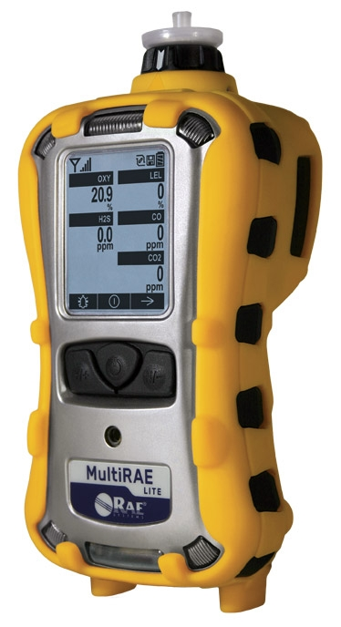
Contaminant Surveying

For surveyor safety, a MultiRAE Lite multigas device will be used to measure VOC, LEL, H2S, CO, and O2 concentrations. To test for these concentrations, surveyors should place the instrument’s probe at the top of the well opening after the well’s plug has been removed. If the well is a stickup design, the probe should placed at the top of the well after the cap has been removed.

If any concentrations of referred gasses exceed safe limits, or explosive conditions are indicated by the device, surveyors should halt any data collection and allow the well to vent for at least 15 minutes. If levels remain unsafe after venting, well manholes should be replaced and surveying of that particular well stopped.

IV. Surveying and Field Materials

For Field Verification
- Well Inventory Field Data Sheet - Emissions Data
- Well Inventory Field Data Sheet - Location and Condition
- Clipboard
- Pen/Pencil
- Facility Well Record Folder(s)
- MultiRae Lite Multi Gas Monitor
- Camera
- Flashlight
- Trimble Ranger GPS with Trimble Pro Series 6H Receiver
- Socket Wrench (for well caps)
- Bolt cutters
- Well padlock keys
- Paper towels
- Rubber gloves
- Brush
- Distilled water
- Marking/Spray Paint (For temporary permit number application)
- Solinst Water Level Meter (for measuring LDNAPL and groundwater depth)
- Tape measure (for measuring well diameter)

For Post-Verification
- New folders or binders (for organizing updated documents)
- Updated documents (permits, records, decommissioning) for each well
- Global Information System (GIS) software
- New well caps (Number to be determined)
- Well tags
- Adhesive (To apply well tags)

